Albert Jordaan

Pacman Pseudocode

Pseudocode is the documented outline or draft of a program. It is written as text, not in a programming language, so it cannot be compiled or executed. It does not require strict syntax, but instead serves as a plan of how the program will be constructed and function. The process of writing pseudo code involves:

Step 1: Decomposition

Break down or decompose the problem.

- Summarise the aim of the game in 1-2 sentences.
To control Pacman (a circular sprite entity) using the arrow keys on computer keyboard moving Pacman safely through a maze full of pellets. The aim is to make Pacman eats all of the pellets and avoid the four maze wandering ghosts. The ghosts are trying to catch Pacman, when one of them touches Pac-Man, a life is lost. When all Pacman’s lives have been lost the game ends.

This is the Purpose section of the Block Comment at the beginning of the Form1.cs file.

- Give a full description of the game. Explain how the game works to someone who has never played the game before.
What characters are in the game?
- Four Ghost Characters
- One Pacman Character
What does each character do?
- Pacman - moves around the maze by keyboard press, eats the pellets as it moves onto it.
- Ghosts – moves around the maze in a certain pattern, once it collides with Pacman it removes one life from Pacman, if Pacman has zero lives it will end the game or bring it to a stop.
How do the characters interact?
- Ghosts and Pacman collision – Pacman loses one life and respawns at a respawn location becoming temporarily invincible to the ghosts interaction.

How do you win the game?
- Pacman eats all the pellets in the maze.
How do you lose the game?
- Pacman loses all his lives.
This is the Description section of the Block Comment at the beginning of the Form1.cs file.
- For each character, identify all the actions needed for this character.
- Ghost 1 (Pink): Tries to ambush Pacman. To ambush Pacman the pink host will need to know where Pacman is on the outer inner regions of the map and take one of the close intersections near Pacman on the inner area on the map to try to ambush him as he leaves the outer area.

- Ghost 2 (Blue): Tries to chase Pacman. For blue to chase Pacman he must know pacmans location and the most efficiently route to chase him as he travels himself.
- Ghost 3 (Orange): Movements are random. For this to occur we will need the ghost to run a script for a certain boundary area to move and have intervals where movement direction is random, we want a boundary and it to not be two random, mainly just the intersections it takes. The reason for this is so it does not ruin the games level of mechanics and is due to random luck.
- Ghost 4 (Red): Movements are random. “Same as ghost 3” but boundary is different
Then for each action, list what will happen when the action is carried out.
- What are the extra features or functionalities that are not essential to the basic game?
- More than one ghost character
- Part of the map that teleport you to the other side
- Power ups
- Extra points from fruit bonuses
- Game Hud.
- What are the curly issues that will still need to be resolved?
- Ghost movement
- moving through the maze with maze collision for the characters.

Step 2: Form Design

What will the form look like?

- Sketch the form at design time? When the game is running?
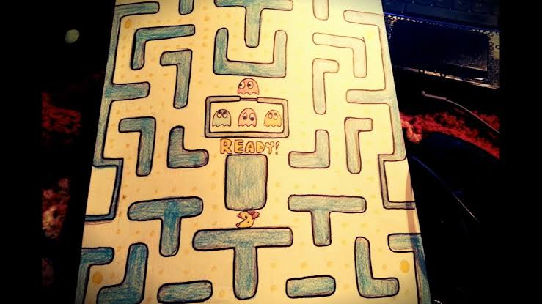

- What controls and components will you need?
- To play the came you will need keyboard arrow key controls

- What will the user do? What events will be needed?
- The user will control Pacman using the keyboard keys.
- Keyboard keypress event

Step 3: Abstraction

Identify the characteristics that distinguish one character from another:

- How many classes will be needed? What will each class be named?
Pacman – “Pacman” - child class
Ghost – “Ghost” - child class
Character – “Character” - parent class of ghost and Pacman
Controller – “Controller”
Form – “Form1”
- What is the purpose of each class? This is your class comment.
- Form1: Where I will display the game playing interface that contains the Pacman, ghosts, maze (that Pacman must traverse throughout), and displayed score. Within this class contains user interactables objects and functionality

- Pacman: The class where everything that involves the sprite Pacman and its functionality is kept. This functionality includes the sprites movement throughout the maze including wall collision, the sprites different animation states according to the users input by arrow key, how Pacman’s movement effects the map as he moves (aka eats kibble and other entities and leaves the map square blank afterwards). It also is draw Pacman onto the form from a specified location.

- Ghost: This is the class that contains the drawing of the ghost sprite onto the form, the ghost sprite movement and its functionality of how it interacts with other object aspects. The sprite image variation is displayed as the timer ticks.

Step 4: Encapsulation

Build your classes:

- For each class, list all the fields that will be needed.
- For each class, list all the methods that will be used. Keep in mind how the classes will interact with each other. What information needs to be passed in and out of the methods?
- Draw UML class diagrams.
Show the relationships between your classes.

Step 5: Iterative Refinement

For each method:
- Name the method so that its purpose is obvious.
- State the purpose of this method in one statement. This is your method comment.
- Break each method down into sub tasks.
- Break each sub task down again....
- .... until they are single statements that can be translated into code.

Step 6: Now you can start coding!

Step 7: Identify extra functionality that will improve your solution.
- Sound

- Bonus points
- Pause button
- Multiple forms
- Menus
- Multiple lives
- Instructions, credits
- ………..

